Product Description

Providing A Practical Solution For Deploying Oracle SBCs in AWS
Overview
As an industry leader, Oracle has sold and deployed thousands of SBCs in colos, on premises, in central offices, and in private clouds. However, the VoIP landscape is evolving. Public clouds (today led by AWS) are hosting more and more applications and real time communications (RTC) services are just one of many applications that enterprises and service providers are looking to move to the cloud. When offering any type of RTC service a session border controller (SBC) is required. While SBCs have been virtualized, deploying the virtualized systems in a public cloud raises several issues depending on the internal architecture of the SBC.
With Oracle, the internal SBC architecture issues are compounded by commercial issues regarding Oracle support for deployments in competitive cloud providers. Eastwind can help bridge the issues enabling Oracle users to leverage their SBC knowledge and network wide licenses when they extend their networks into the AWS public cloud. Eastwind can provide an AMI for the SBC along with hands-on technical assistance to install and configure the SBC in the cloud. Equally important to the initial installation and configuration is the ability to troubleshoot and resolve issues. The fact that Oracle will not work with AWS (or any public cloud provider) to troubleshoot issues presents a large problem for those looking to deploy the Oracle SBC in AWS. Again, Eastwind can bridge the gap. Eastwind takes responsibility for working with AWS and Oracle to resolve any technical issues in deployments.
For many users today, AWS is a vehicle for international expansion. Many users have existing hardware-based deployments, but they view a public cloud as a cost-effective option to turn up remote points-of-presence with a minimal financial commitment. The Oracle SBC VNF is a great fit for that type of deployment. Eastwind (US-based) has years of experience working on worldwide deployments on a 7x24 basis. However, AWS does have its deviations from region to region. Eastwind has experience working in multiple regions and we always deploy a system ourselves in the specific region our customers are looking to deploy in before we work on a customer system.
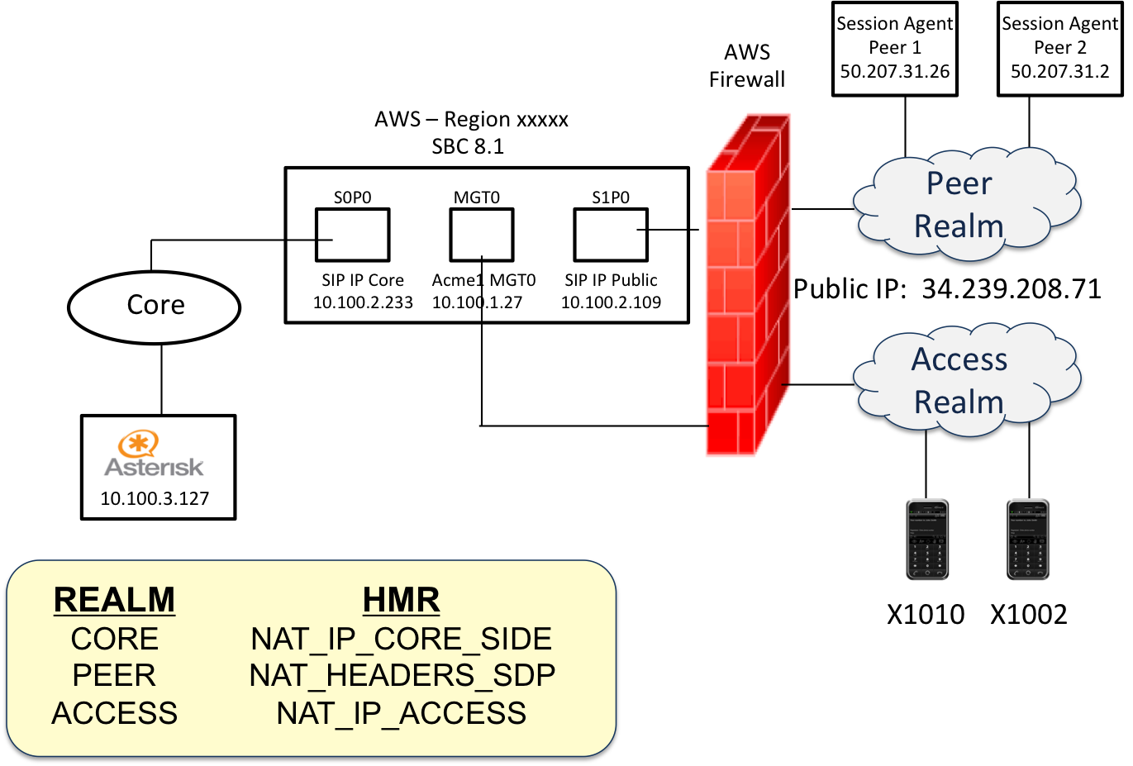
Figure 1 –HMR Development Work Required to Successfully Pass Through the AWS Firewall

How Does The Process Work
From a sales perspective Eastwind, as an Oracle OEM, can sell, deploy, configure, train, and support users in their AWS deployments. However, regardless of where a user purchases the SBC software, Eastwind will gladly work with them on services.
Once Eastwind is engaged with a customer deployment, we will review the system requirements with the user prior to turning up the system. Once we understand the final configuration goal, we enable the customer to access our AMI. Once the AMI is deployed in the customer’s AWS instance, Eastwind then builds the header manipulation rules enabling the system to function properly in the AWS environment. Once the system is operational, customers can configure the system as they would for any SBC deployment.
After the system is operational, Eastwind continues to support the customer. Due to the nature of the deployment in AWS, Eastwind needs to be in the middle working tickets with Oracle Support. We gladly open and work any tickets on these systems with Oracle. Customers reach Eastwind via our 7x24 Support Line which is staffed by trained engineers. Also, when it comes time for a system software upgrade or if new IP interfaces are required, Eastwind will engage with the customer to configure these new capabilities correctly with the requisite HMRs.

